
Development Request
Aria Systems
Material PO modification and Fabric Color Label

Material PO modification and Fabric Color Label

PO customization
Product: | Aria27
Module: | MA
Customer name: | Robert Gaspard company (ROB20)
Installed Modules: | AP,AR,GL,IC,MA,MF,PO,RM,SM,SO,SR
Parameters setting : | Set up will be sent to MA module.

PO Details
Report Name: Custom Material PO and Fabric-color Label.

Report Objective ( Purpose ):
Custom Material PO will print a Bar code below the PO# . This is to speed up the process of receiving Material Pos.
The custom Label will be designed for the purpose of scanning in a Fabric color instead of keying in a Fabric Color in any screen that requires keying in Fabric followed by the Color field. This label will be printed for all Fabric-color in the Material inventory for the purpose of scanning.

Description:
(Please note: I will be using the word “Fabric” interchangeably with the work “Material” and “Item”. Please note they are one and the same thing, but needed to be used for the purpose of referring to specific screens in Aria.)

Currently:
The customer uses Material PO form A. There is no previous customization to this form.
We would like to take our standard form and introduce a Bar code below the PO#. The Bar code will contain the 6 digit Purchase Order number. This bar code will be of following specification:

Font : (Standard Bar code font used in Aria)
Font Size: 22
Position : Center alignment. Located just below the PO# printed on the first line. (see diagram B)

Diagram A. (Original Material PO form A)

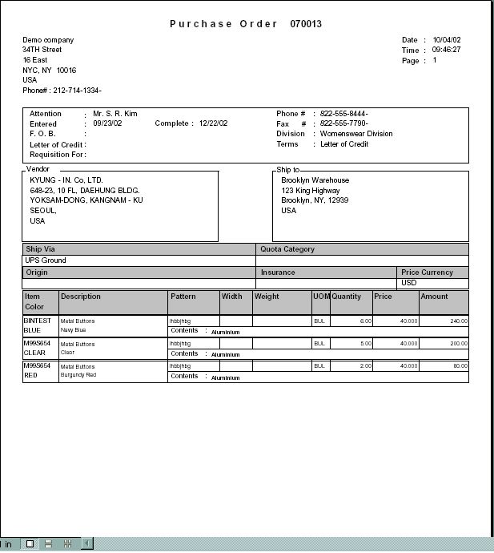

The following page shows the diagram with the BAR code required.

Diagram B. (Required Material PO form A)
(Please note : position of bar code.)

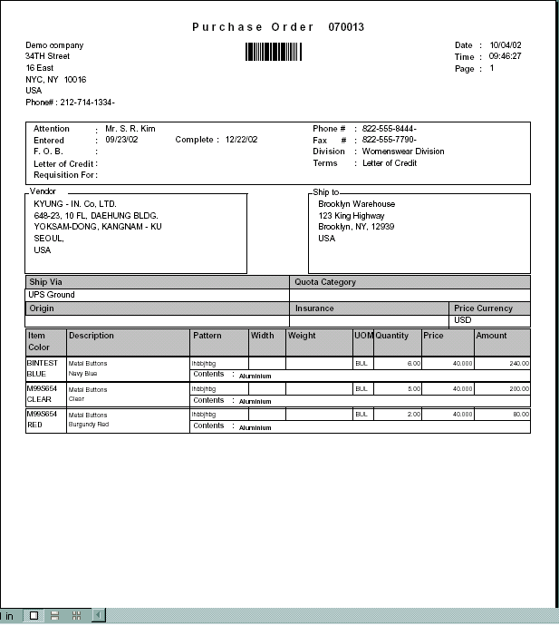

Label Layout
The Label Layout will be very similar to the Style Labels that print in the program POBRCD.
The layout is as follows.
It will print each FABRIC-COLOR as a bar code.
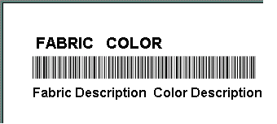

Example of a Label is as follows.
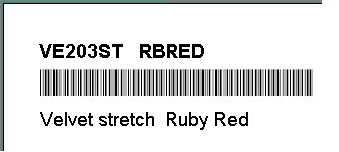

Number of labels in a page : We can fit 3 labels across, and 9 Labels in height (same format as POBRCD label program)

Layout Description
Number | Field Label | Field Meaning-Semantics | Field Format
1 | Fabric | Fabric Code | Chr(7)
2 | Color | Color Code | Chr(6)
3 | Fabric Description | Fabric Description in Code file | Chr(20)
4 | Color Description | Fabric Description in Code file | Chr(40)

.

Option Grid Parameters: To print the labels.

Presentation Parameters: The option grid will contain most standard options seen in the Material Master list report. The following fields should be included in the option grid that will allow the user to filter the material they would like to print the bar code for.
Parameter Label | Parameter Description (effects) | Operator | Valid Values
Item Type | Material type | Is one of | Types of Material elements and the value to select “ALL”
Item Range | Material Items | In-list | Material master list
Color | The Fabric’s color the user would like to include in the filter | In-list | Color codes list
Only this Warehouse | Material warehouse | In one of | Valid Warehouse list
Material | Select window lets user further select the Material from the material master list | In-list | Material master list

Mechanics:
The Label printing program will be a link on the Material – Output menu.
This will be a program that allows user to select the Materials based on the option grid that will run once clicking the link. This option grid allows the user to print the list of materials in the Label fabric specified above. We can print up to 27 labels in one page because the label matrix defined allows user to print 3 material labels across, and 9 in each column in a regular A4 paper.

Development Cost | $1200.00
Customer signature
  Date signed
Payment Terms | 50 % due upon signing.  50% due upon delivery of the project.  (No work on this project will begin until the deposit is received)
Estimated completion time

